Frequently asked questions (FAQ / Q&A)
Applying
Q1: How can I apply for a Job?
Please apply through our website. Fill out the application form online and we will advise you by email if there are any job vacancies.
You need to have the right to work in Australia. We must check your ID or Passport and Visa when you attend our farm induction (see Q13 for more information)
Q2: How does the job application process work?
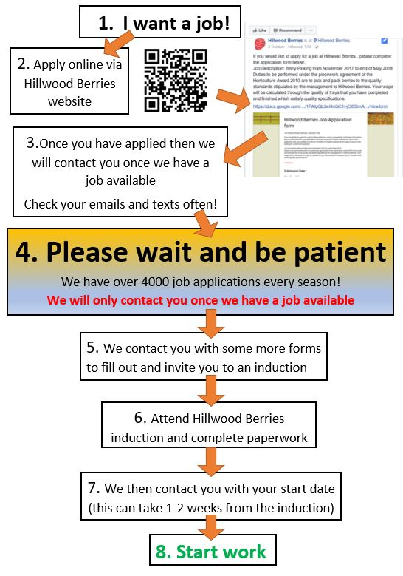

Q3: I want to work at Hillwood Berries, how far in advance do I need to apply?
Our berry season begins in early November through to May. You can apply from our website as a fruit picker before October. There are also a few jobs vacancies during the period between the middle of July through to September.
Q4: Will it be faster to get a job if I go to register at farm office?
No. We use same online system for recruiting. You will still need to fill out the online application form, once we have work available we will contact you via email. Only ring the office if it is an emergency.
Q5: When can I start to work?
We will contact you via email only when we have work available. Please be patient. Our HR team will contact you with an Induction date if your application is successful.
Q6: If I have worked with you, do I need to apply again?
Please contact our HR team via email with your staff ID number, full name and nickname. We will contact you directly.

Work
Q7: I only want to work 2-3 weeks, should I work at Hillwood Berries?
No, we don't employ people for such a short period of time. We need people who are committed to staying for at least 3 months. If you are after only a few weeks work, we would suggest trying a cherry farm or apple orchard.
Q8: Is the fruit picking job at Hillwood Berries seasonal?
Yes, commencing November, we pick through to the end of May.
Q9: What kind of berries do you grow?
We grow strawberries, raspberries, blackberries and blueberries.
Q10: How many days a week will I work?
On average 4-6 days (Variables: Fruit/Weather conditions)
Q11: What are the working hours in a day during picking season?
We usually start at 6AM, and finish at about 3-5PM, it can be 6AM-6PM – it really depends on the weather and fruit productivity. Lunch break is 30-45 minutes. Hours vary on fruit/weather conditions.
Q12: What is the work like?
It is a labour intensive job, you will probably find the work very challenging in the beginning. The role includes both picking and packing, it’s repetitive and could be long hours. It normally takes 2-4 weeks to become a competent picker, if you have never worked physically in your previous jobs, we may suggest that working on a farm is not the right option for you.
Q13: What is the Job Description?
Duties are performed under the piecework agreement of the Horticulture Award 2010 and are to pick and pack berries to the quality standards stipulated by the management of Hillwood Berries. Your wage will be calculated by the quantity of trays that you have completed which meet quality specifications. There may be some hourly work available, such as weeding, roping, etc. The hourly rate will be in accordance with the Level 1 Horticultural Award.

On Your INDUCTION day
Q14: What do I need to bring?
Bank Account details (only Australian bank accounts are accepted)
Tax file number (TFN)
Superannuation details (If you do not have one then we will set up an account with Sunsuper for you)
I.D. - Passport and a valid working visa or Australian Driver’s license and Medicare card (or other proof of Australian Citizenship / permanent residency status).
You must complete all paperwork before you are able to start work.

For work
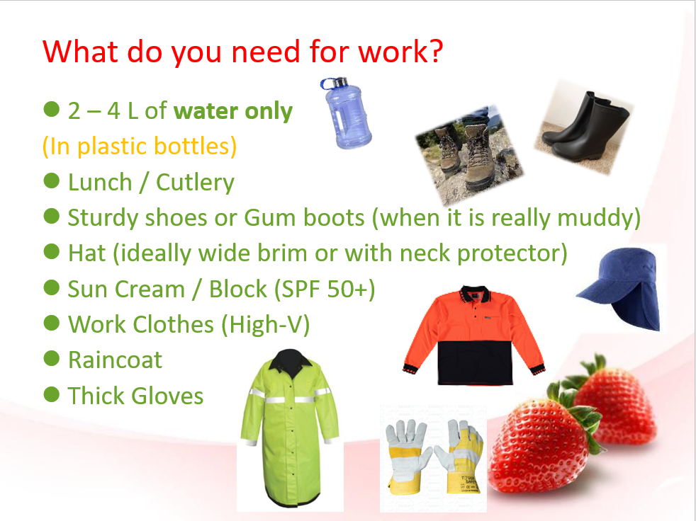

2nd year visa
Q15: Do my days working at Hillwood Berries count towards my second year working holiday visa?
YES, if you are on working holiday visa 417. On your payslips, there are the dates and both the company’s and your details. We don’t sign other forms since all the details you need for applying for your second working holiday visa are stated on your payslip/s. When you apply for your 2nd year visa, please make sure to attach all your payslip/s. More information of your visa, please contact the Immigration department of Australian Home Affairs.

Pay
Q16: How much will I get paid?
Most jobs on the farm are paid as per piece rate contracts.
- Piecework rates have been calculated in order to comply with the Level 1 Horticultural award. They allow an average competent worker to earn 15% more than the basic hourly award rate of $23.66 per hour at Casual rates under the same award.
- Gross weekly pay is worked out by multiplying the piecework rate by the amount of work an average competent worker would complete. This amount is calculated to compare it to the pay of a worker paid hourly rates for 30 hours of work per week.
Q17: How often do I get paid?
We pay fortninghtly. Every 2 weeks before Thursday we transfer directly into your bank account. You must have an email to receive your payslip.

Transportation
Q18: How do I get to Tasmania from the mainland?
With car: you can take a ferry from Melbourne by booking tickets via Spirit of Tasmania.
(https://www.spiritoftasmania.com.au/ )
or
You can take an airplane to Launceston airport. There are direct flights from Melbourne, Sydney and Brisbane via Jetstar.( http://www.jetstar.com/au/en/home), Virgin Australia or Quantas Airways.
Q19: How do I get to Hillwood Berries farm?
By Bus: Lee's Coaches ( http://leescoaches.com/timetable)
http://www.railmaps.com.au/routedetails.php?RouteSelect=453
By your own car: You will need to arrange your own transportation to work.
Q20: I have my own vehicle, how do I drive to Hillwood?
From Launceston (25 minutes): Travel north on the E Tamar Hwy/A8 to Mt Direction. When past the Caltex Service station, take first turn left into Hillwood Rd. Travel 3 minutes, to 139 Hillwood Rd. You will see our Hillwood Berries Logo at the gate.
Q21: Do I need a car for this job?
Yes- you will need a car. It will be very difficult to find a job in Tasmania if you don’t have your own transportation. We strongly recommend that you buy a car or car pool with your friends.

Accommodation
Q22: Where will I live?
You are responsible for finding your own accommodation.
Here are some of the accommodation options available:
- Share-house :, we suggest you find something in the Mowbray/ Newnham area− close to University of Tasmania.
- Use gumtree: https://www.gumtree.com.au/
- Caravan Park : There is a caravan Park at Low Head close to George town. For more information see their website or call (03) 6382 1573.
Link : http://www.lowheadtouristpark.com.au/
Q23: Do you provide accommodation?
We don’t have any accommodation is available at the moment.
Q24: Do you have a camp site at the farm?
Sorry, no.

Other
Q25: What is the weather like in Hillwood, Tasmania?
Tasmania has a cool temperate climate with four distinct seasons.
Summer (December – February ):15°C ~30°C
It is still cool in the morning when you start to work, however outside temperatures sometimes can reach 35 degrees around lunch time.
It is best to wear a big jacket with short T-shirt inside
Winter (June – October): -2°C~ 12°C
The temperatures are generally the wettest and coolest months. Make sure you have enough warm clothes to work in Tasmania during Winter.

Q26: Is there a microwave to heat up my lunch at work?
Yes. We provide an amenities block for staff where you can take lunch break. Desks, chairs, hot water, and toilets are available.

Q27: What is the best reception of phone in Tasmania?
If you are coming to Tasmania, we highly recommend that your phone is on the Telstra network (Boost / Aldi are good options, as they run on the Telstra network), or most of time your phone will be in SOS mode.

